***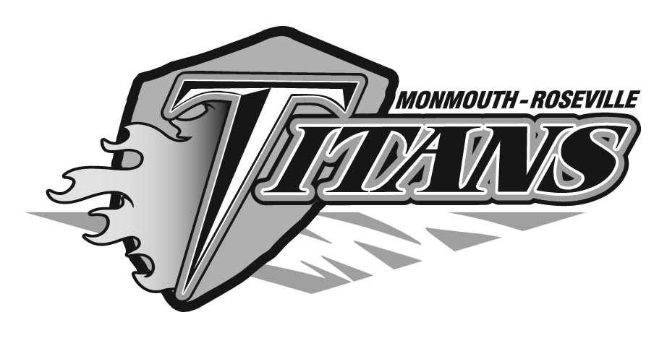*RAES**

**Monday**

***WG*** Beef n Bean Burrito

**Tuesday**

***WG*** Chicken Broccoli Alfredo

**Wednesday**

Hamburger/ ***WG*** Bun

**Thursday**

***WG*** Crispy Drumstick/Cornbread

**Friday**

Big Daddy’s Cheese Pizza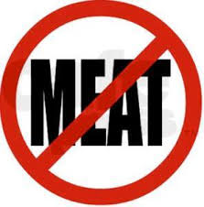 ***WG***

**Monday**

***WG*** Soft Shell Tacos

**Tuesday**

***WG*** Crispy Chicken Sandwich

**Wednesday**

***WG*** Hot Ham N Cheese****

**Thursday**

Salisbury Steak w/ ***WG*** Bread/Butter

**Friday**

***WG*** Italian Dippers 

**Monday**

Holiday No School

**Tuesday**

***WG*** Philly Cheese Rite

**Wednesday**

***WG*** BBQ Rib Sandwich

**Thursday**

***WG*** Crispy Chicken Tenders

**Friday**

Cheese ***WG*** Ravioli  **w/Bread/butter**

**Monday**

***WG*** Crispy Chicken Sandwich

**Tuesday**

***WG*** Titan Sloppy Joe

**Wednesday**

Grilled Chicken ***WG*** Sandwich

**Thursday**

***WG*** Chili Dog

**Friday**

No Lunch

**Feb 24-28**

**Feb 17-21**

**Pork Products**

 **No Meat Products**

***WG* Whole Grain Product**

**DAILY**

**Hot Sides, Assorted Fresh/Canned Fruits and Milk Choice**

**Feg 10-14**

**Feb 3-7**

***The USDA & State of Illinois are equal opportunity employers. Menu subject to change with out notice. ORDER each Morning***